**In-Class Social Media**

"Don't raise your hand! Just like!"   
An in-class social medium where students can anonymously raise questions without having to interrupt class. Questions are shown in a question box on individual computer screens and can be liked by other students, whose color changes as the number of likes increases. Java was used.

* Student Program Action Screen*

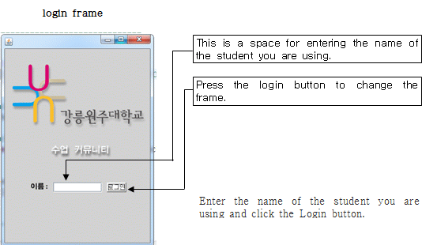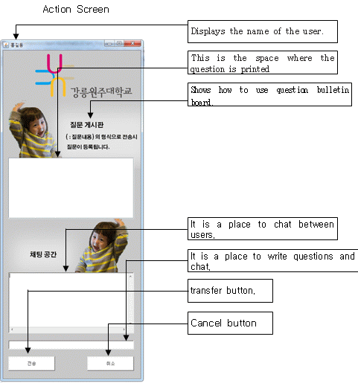

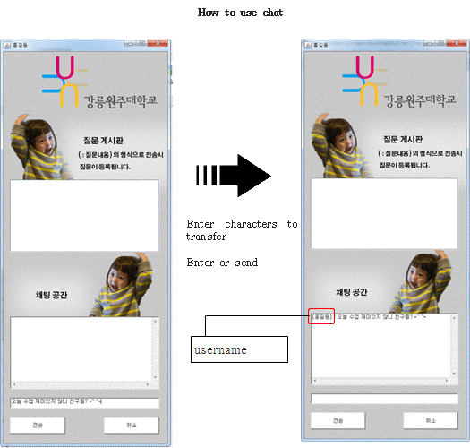

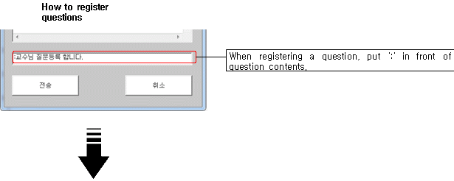

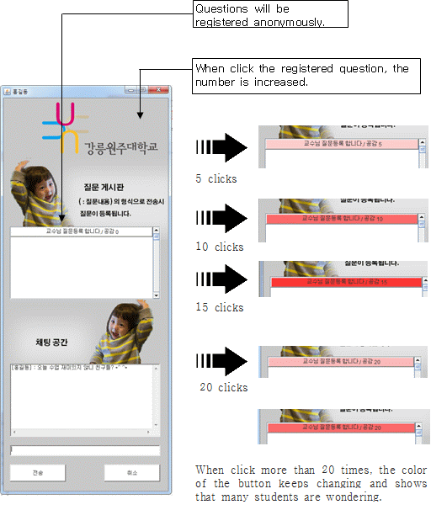

* Professor Program Action Screen*

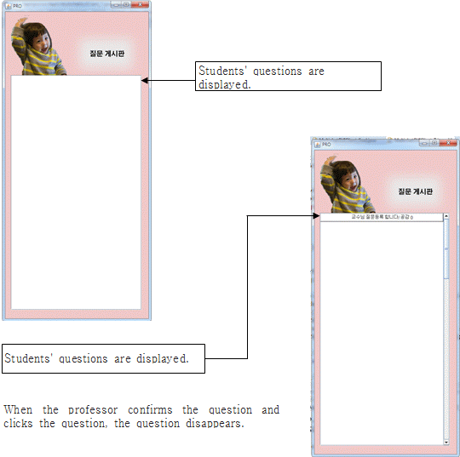

*Execution screen*

